# Assignment Management System

Component Level Design-SE606

Presented by:

Tulshi Das-bsse0811

Maloy Kanti Sarkar-bsse0834

Presented to:

[Md. Nurul Ahad Tawhid](http://www.iit.du.ac.bd/about_iit/individual_teacher/52)

Assistant Professor, IIT, DU

Date: 04.10.2018

## Class Elaboration:

Authentication:

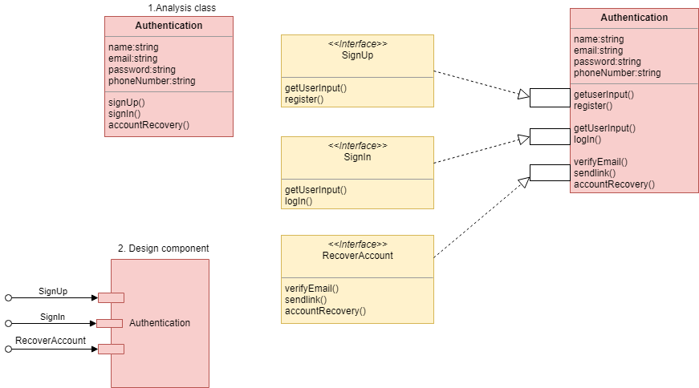

Figure : Elaboration of class Authentication

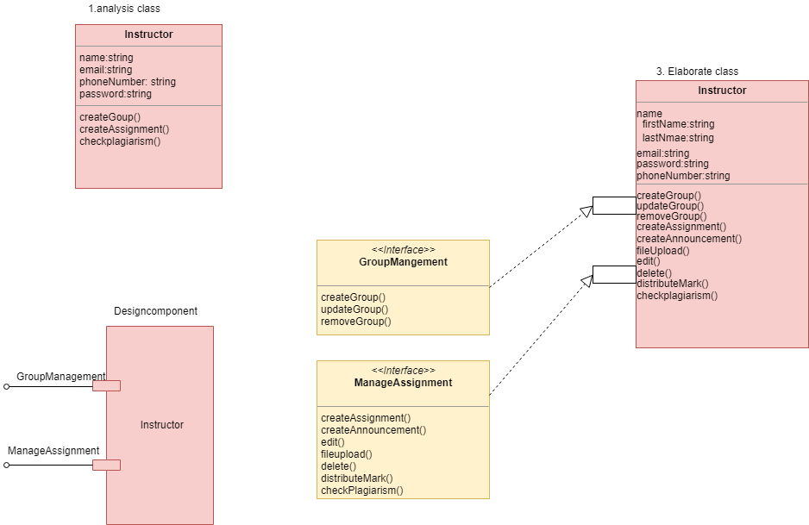

Figure : Class elaboration of Instructor

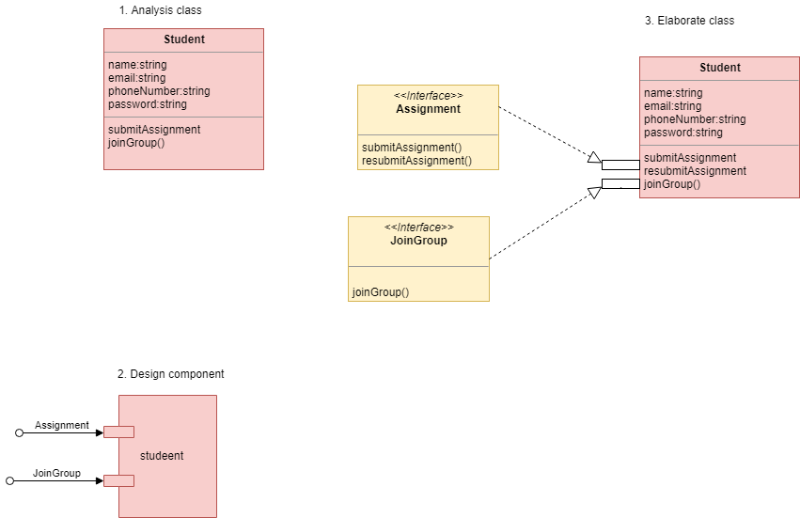

Figure : Class elaboration of Student

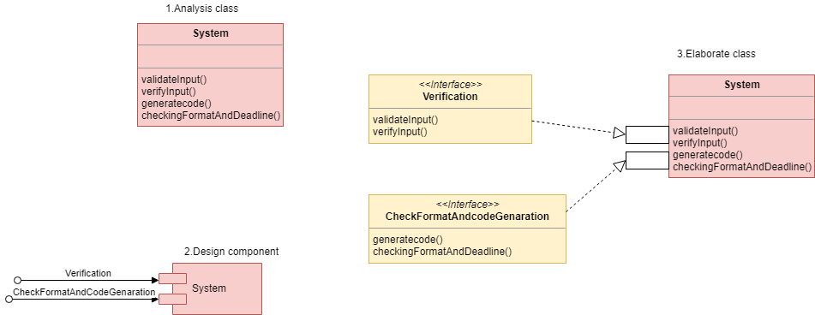

Figure : Class elaboration of System

## Collaboration Details:

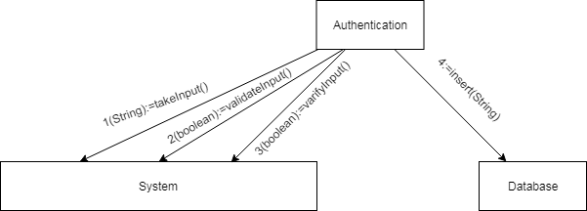

Figure : Collaboration of Authentication class

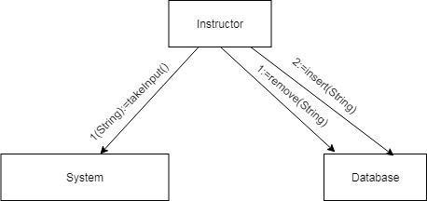

Figure : Collaboration of Instructor class

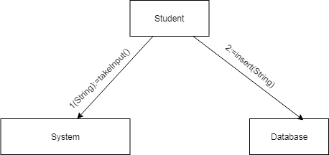

Figure : Collaboration of Student class

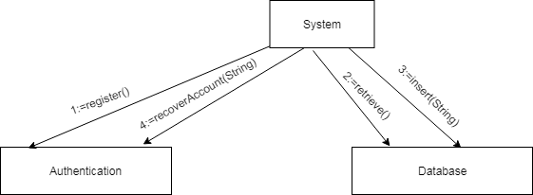

Figure : Collaboration of System class

## Processing Flow:

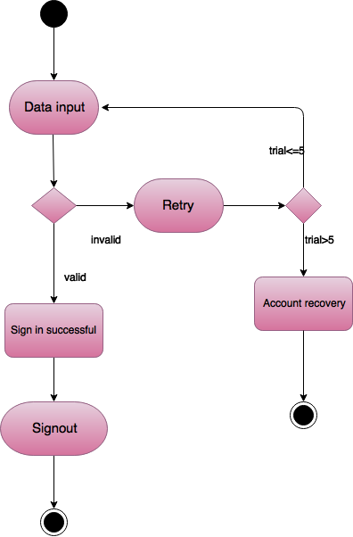

Figure : processing flow of Sign in

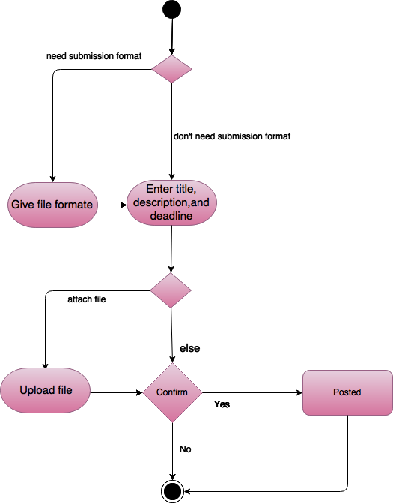

Figure : Processing flow of Post assignment

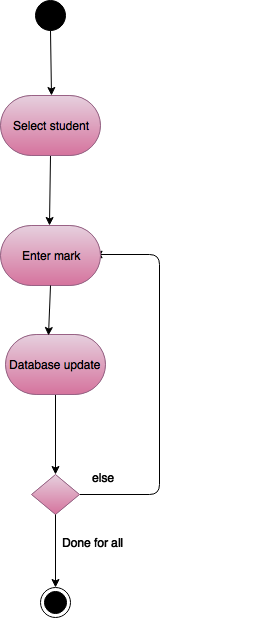

Figure : Processing flow of Mark distribution

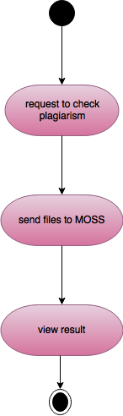

Figure : Processing flow of check plagiarism

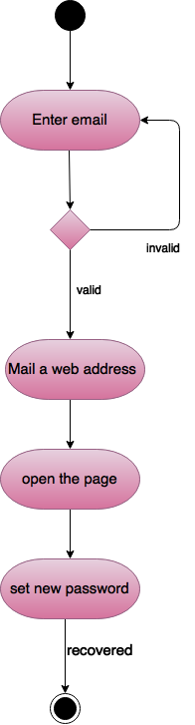

Figure : Processing flow of Account recovery

## Elaboration of Behavior:

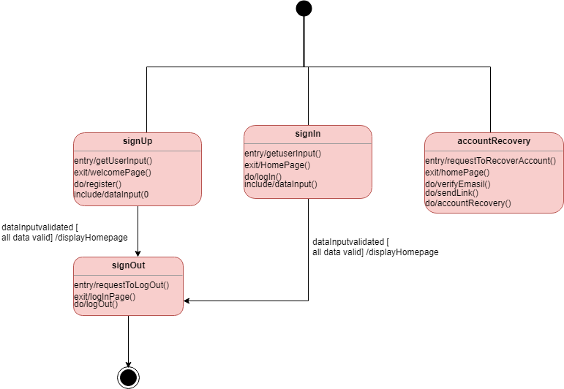

Figure : Elaboration behavior of Authentication

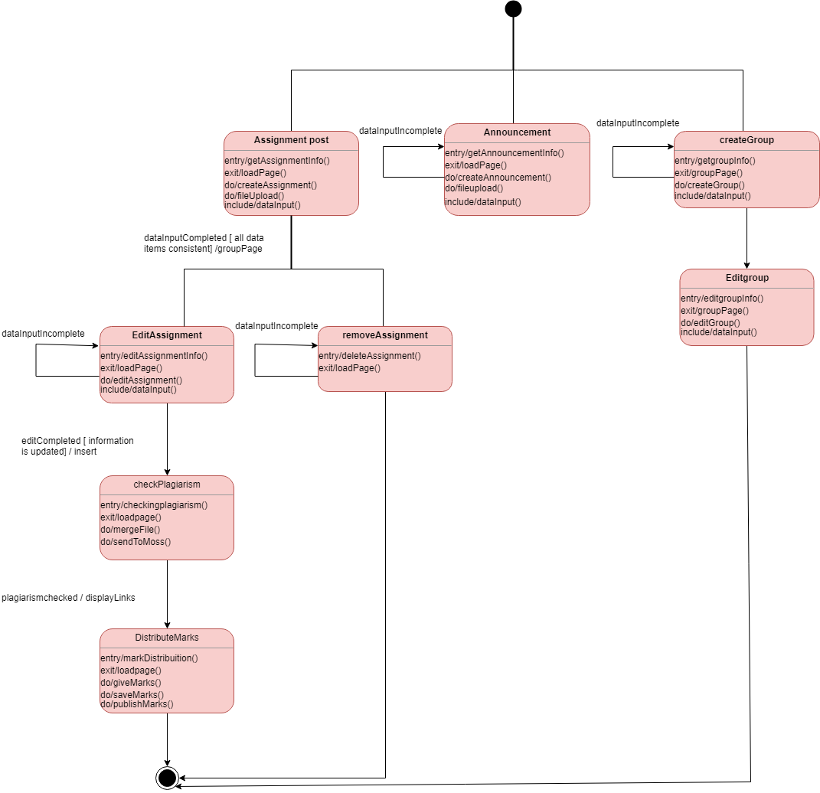

Figure : Elaboration behavior of class Instructor

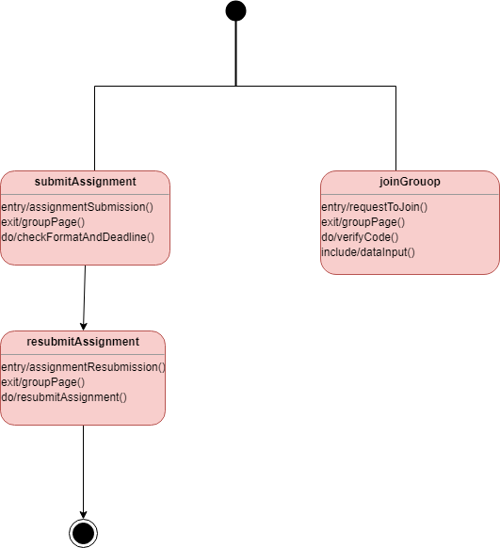

Figure : Elaboration behavior of class Student

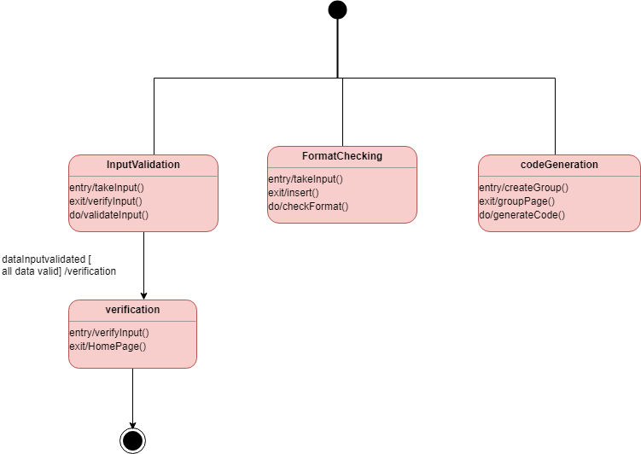

Figure : Elaboration behavior of class System